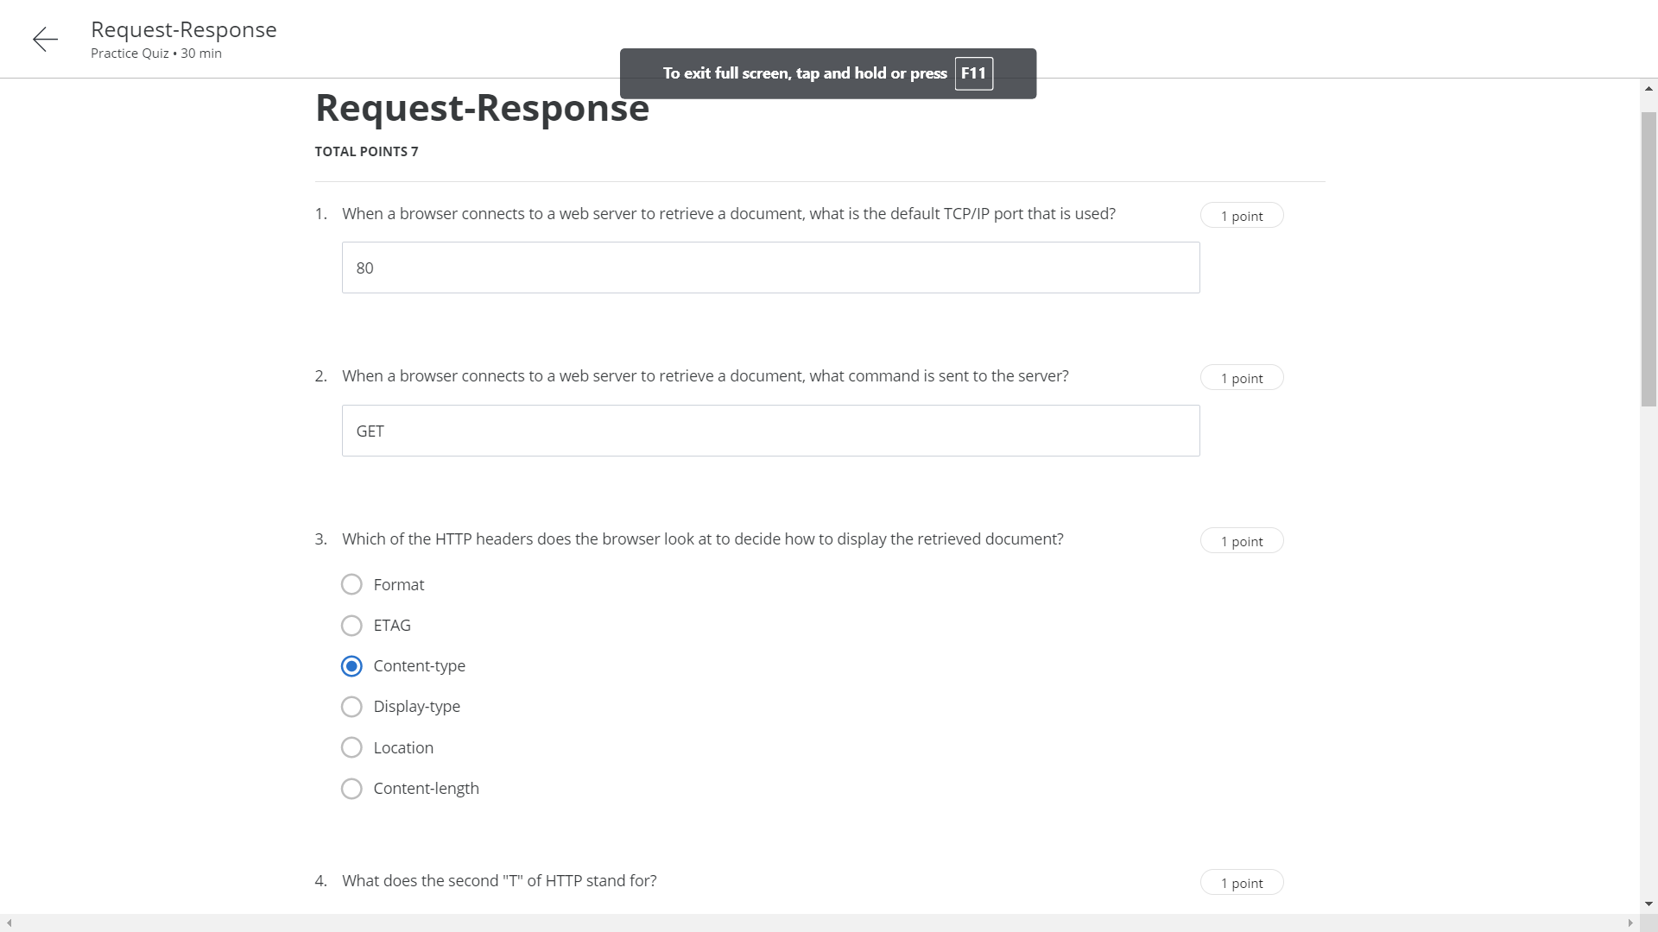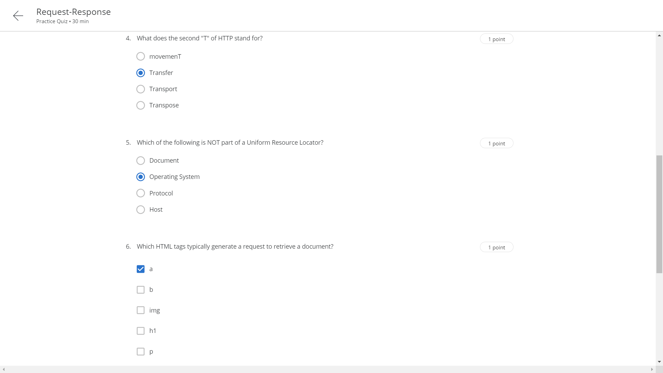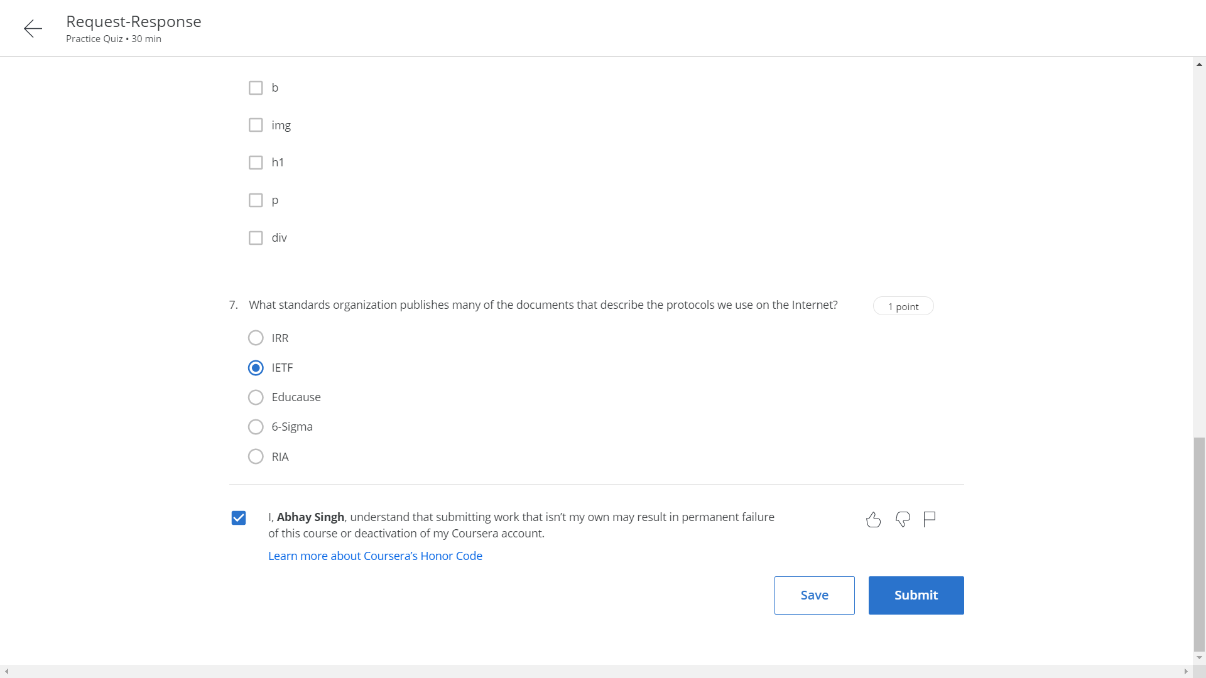

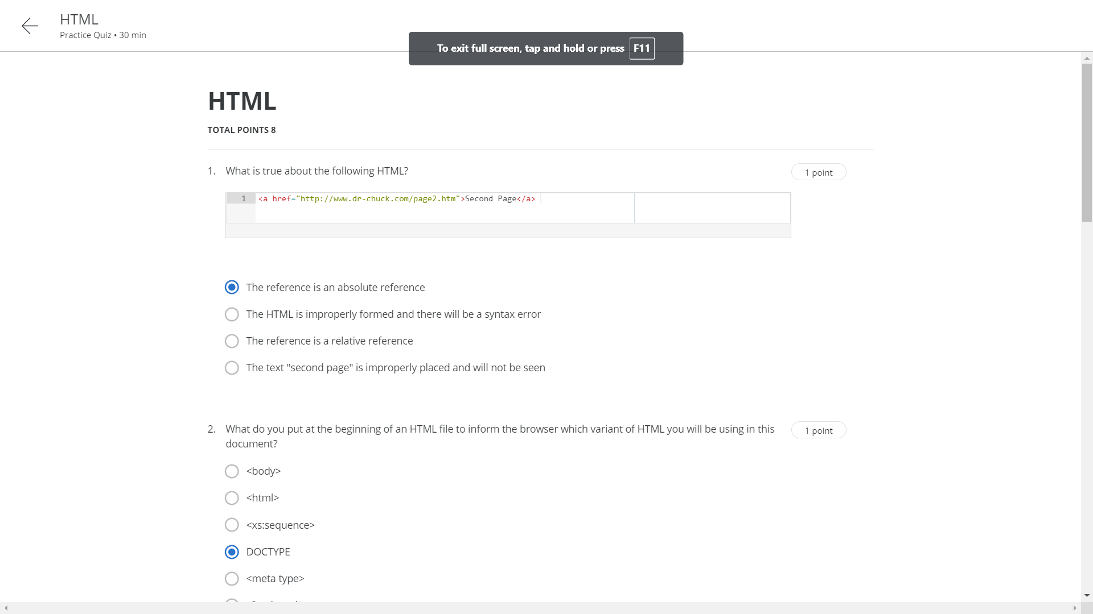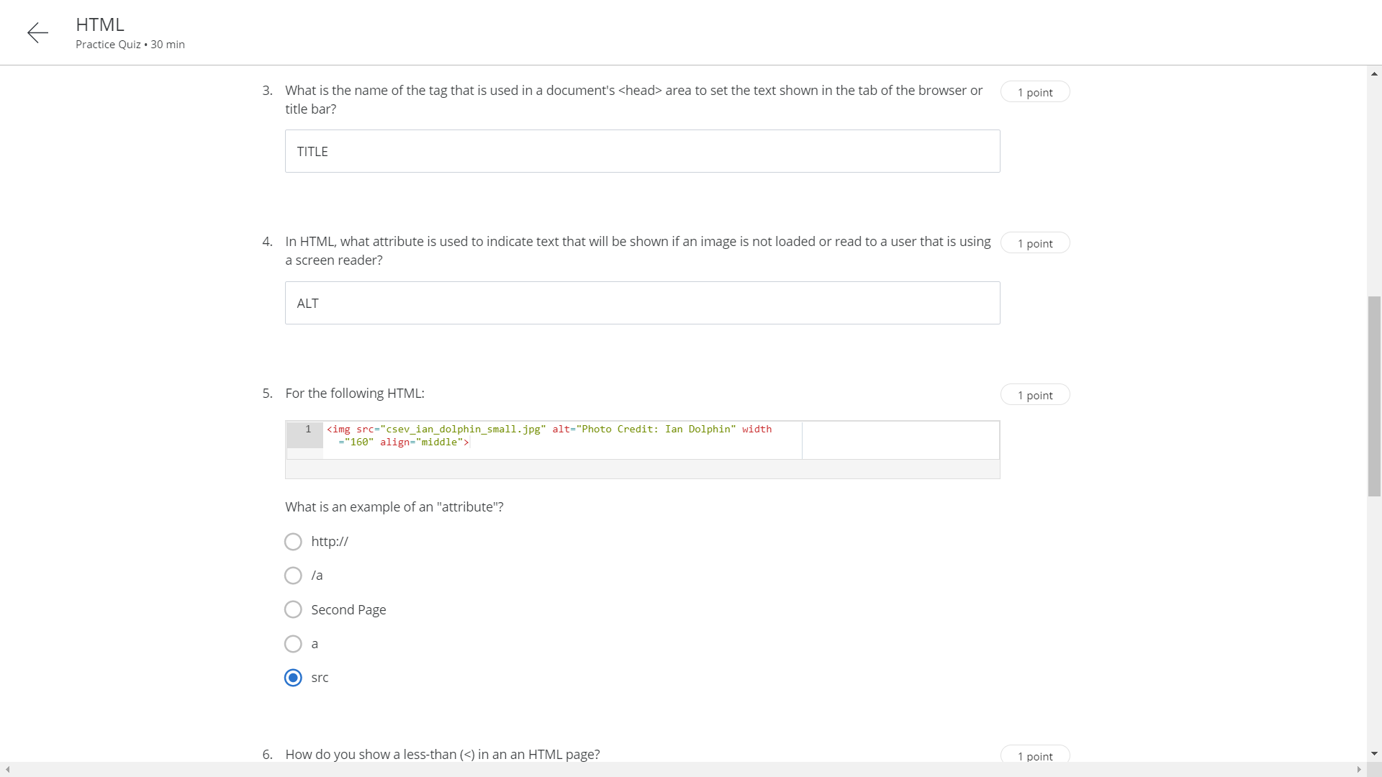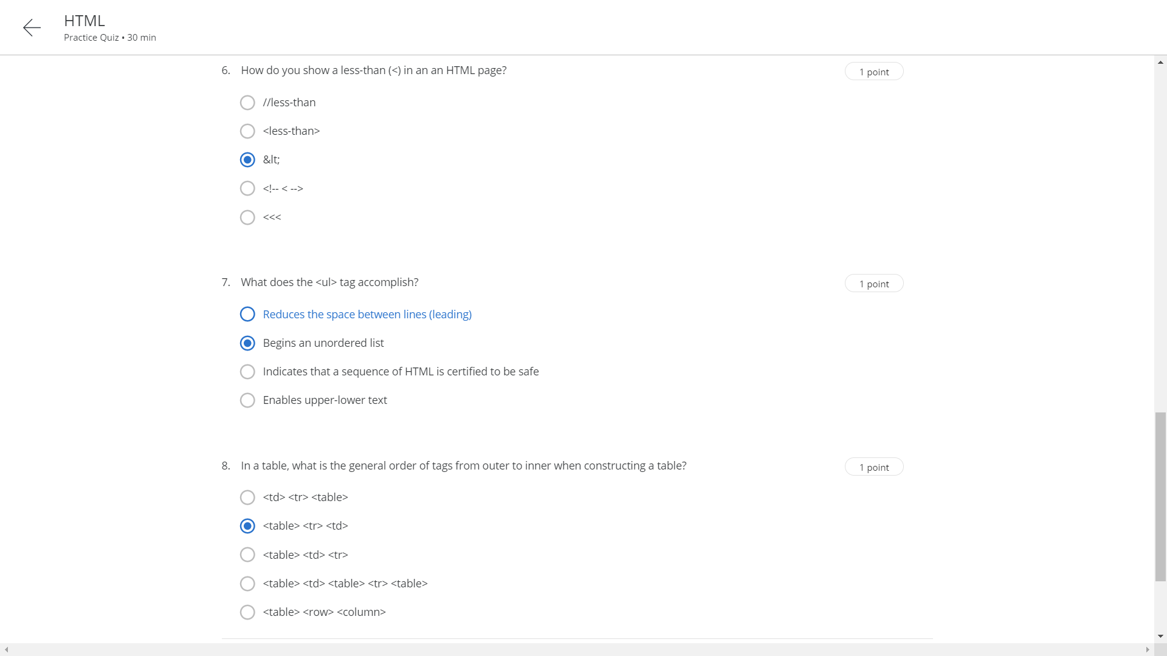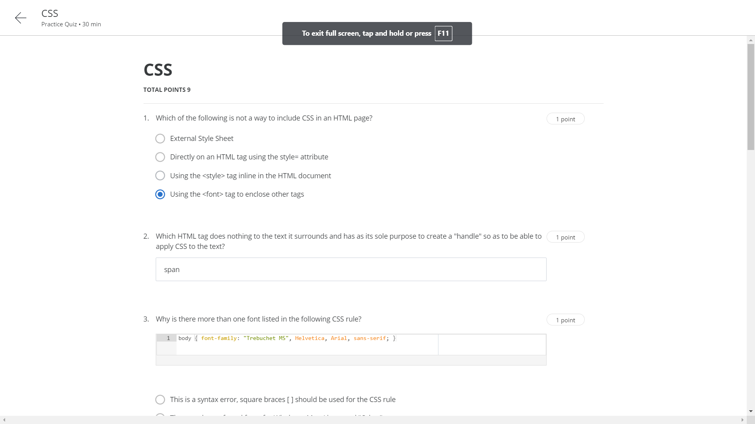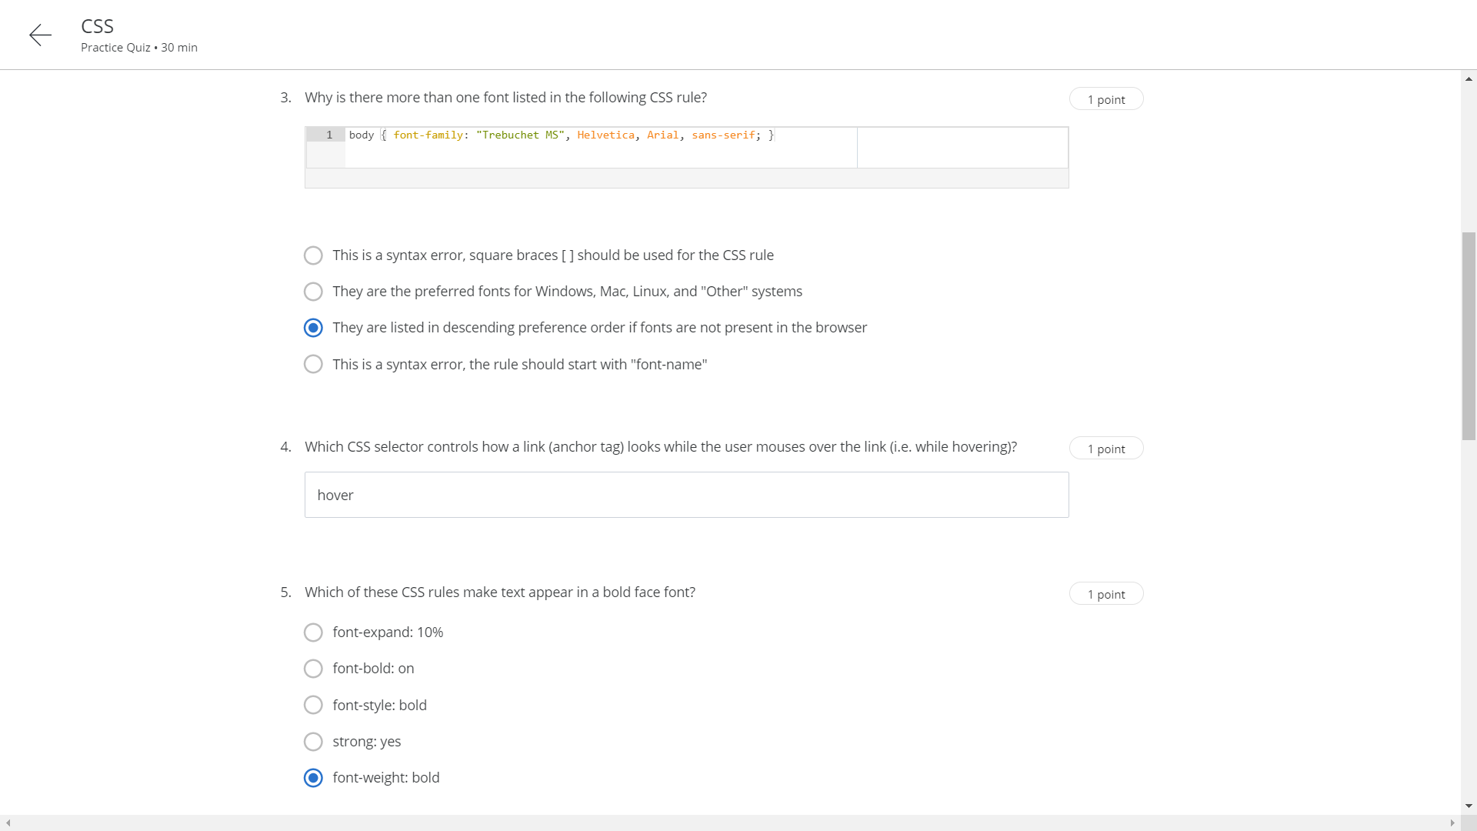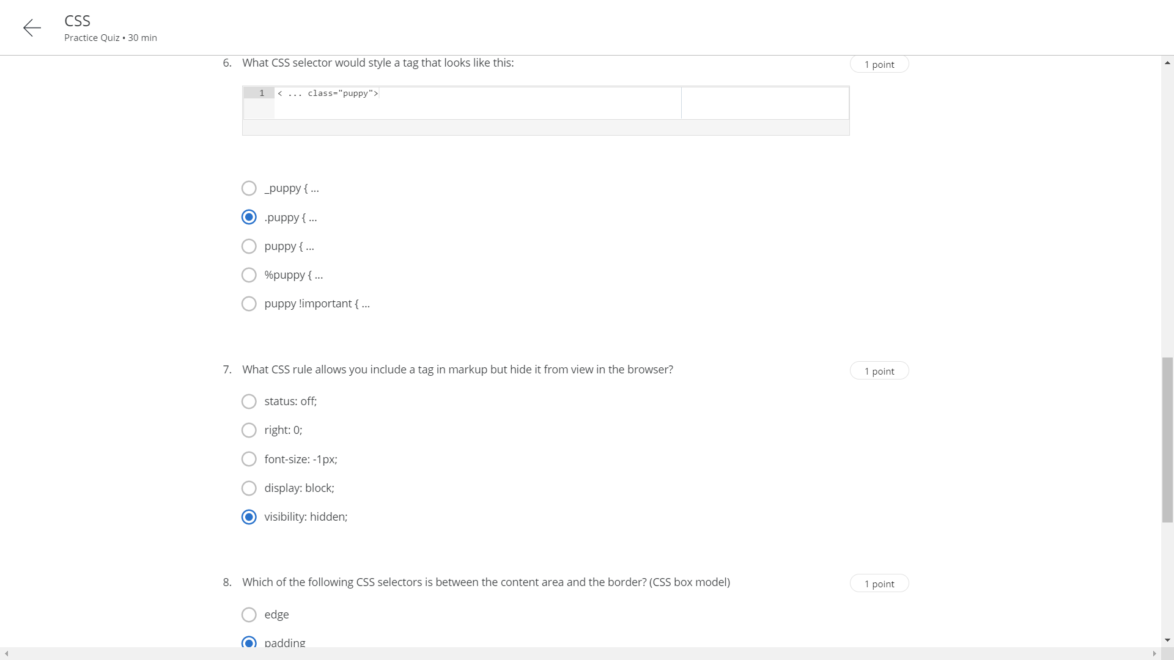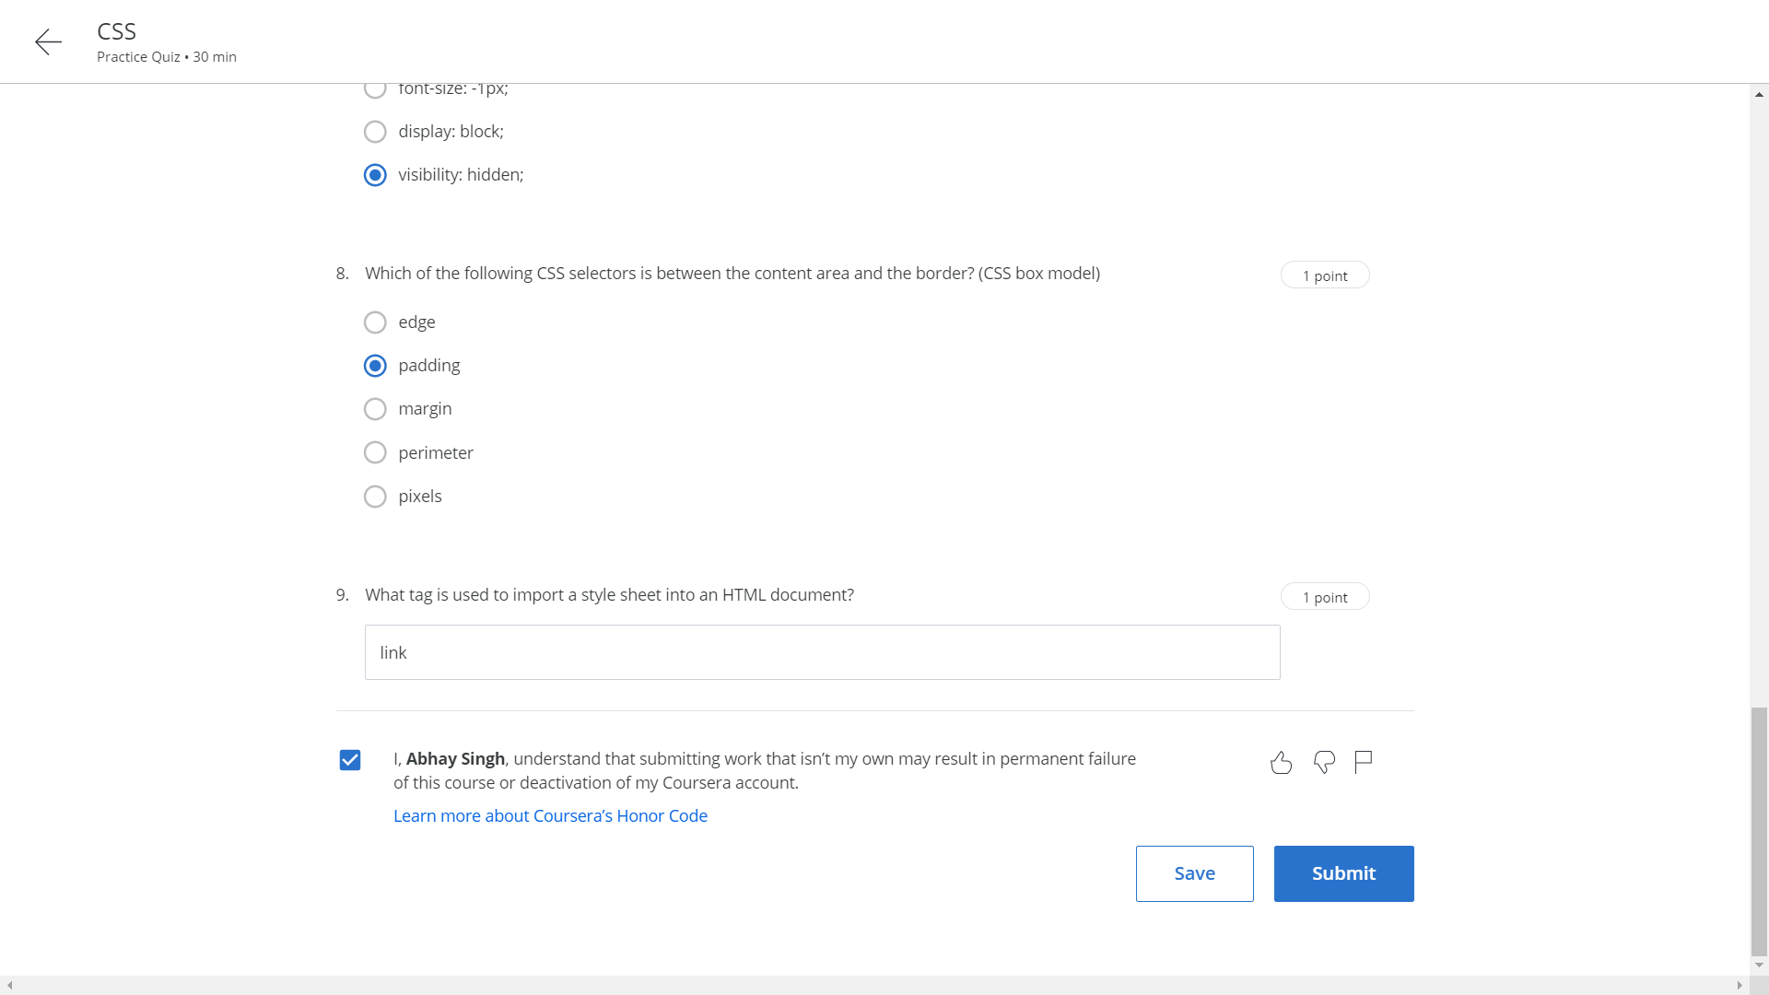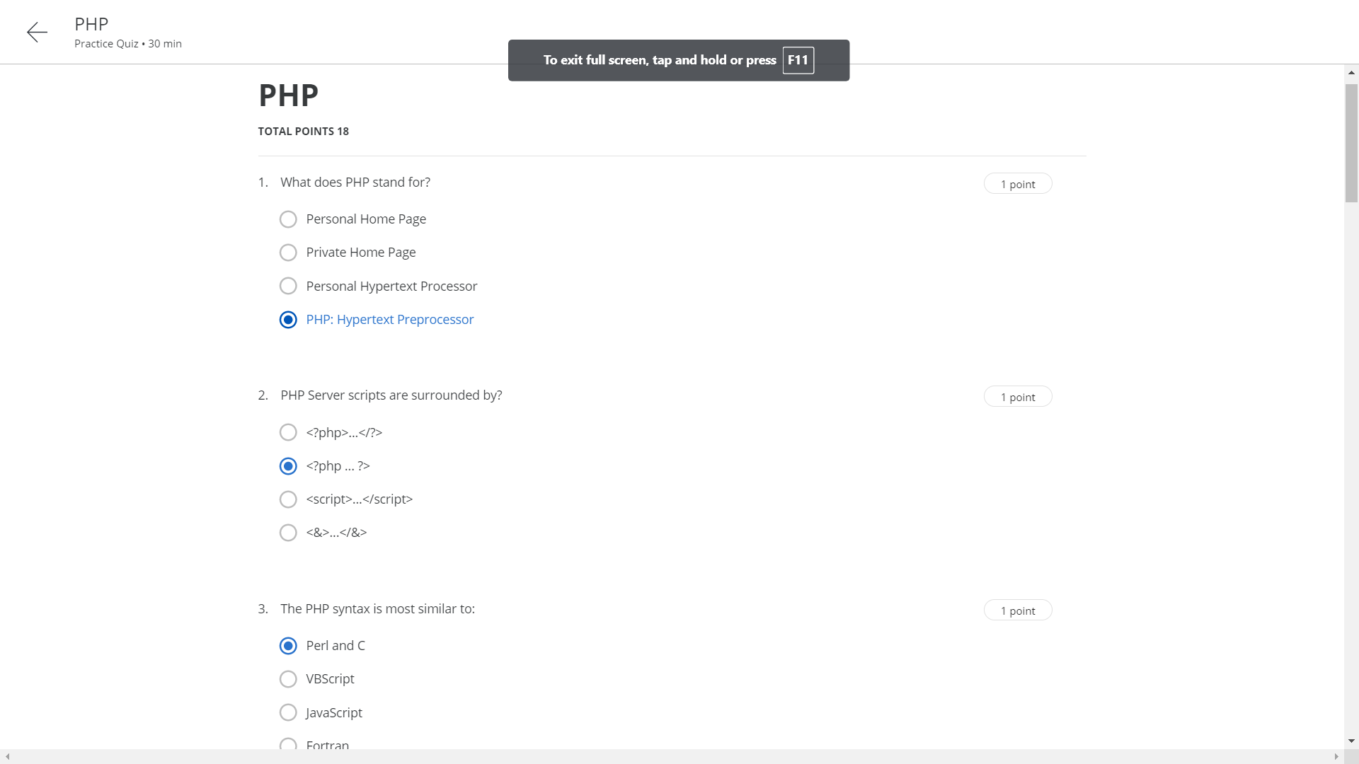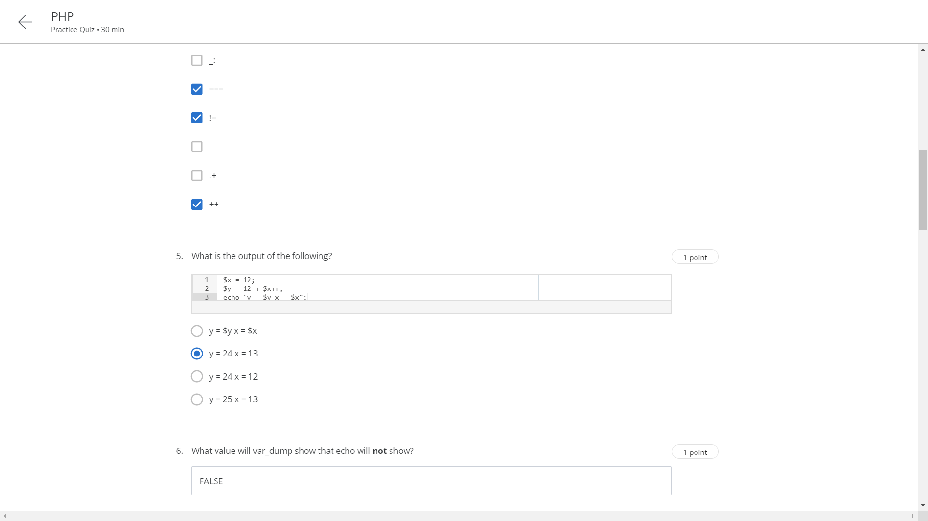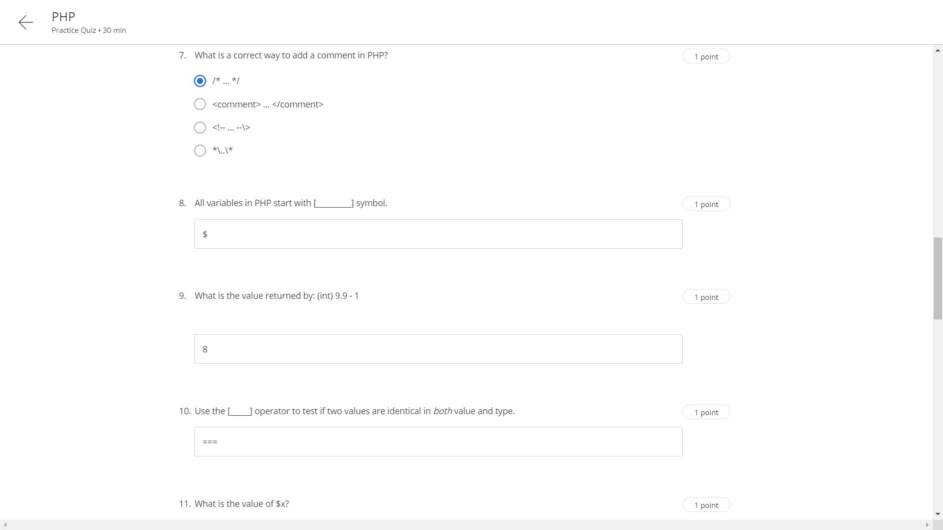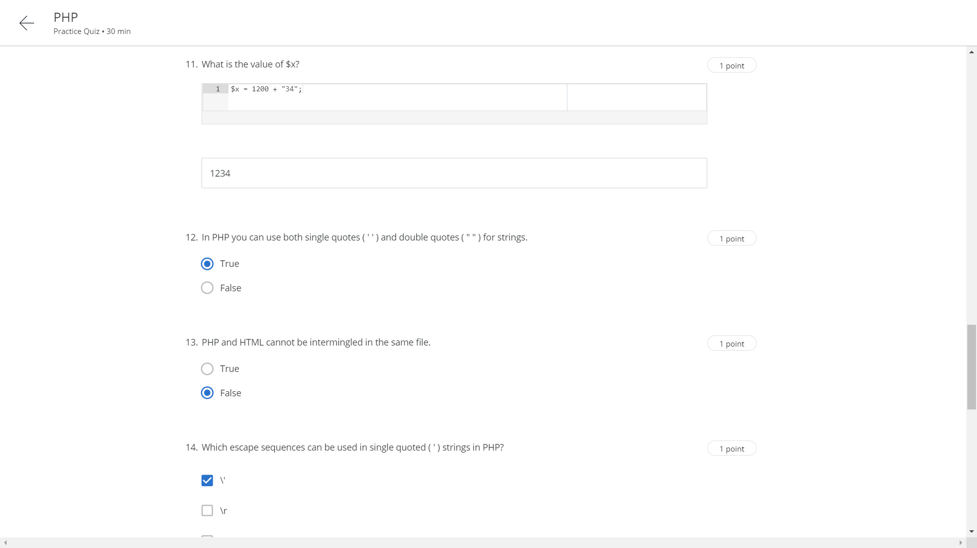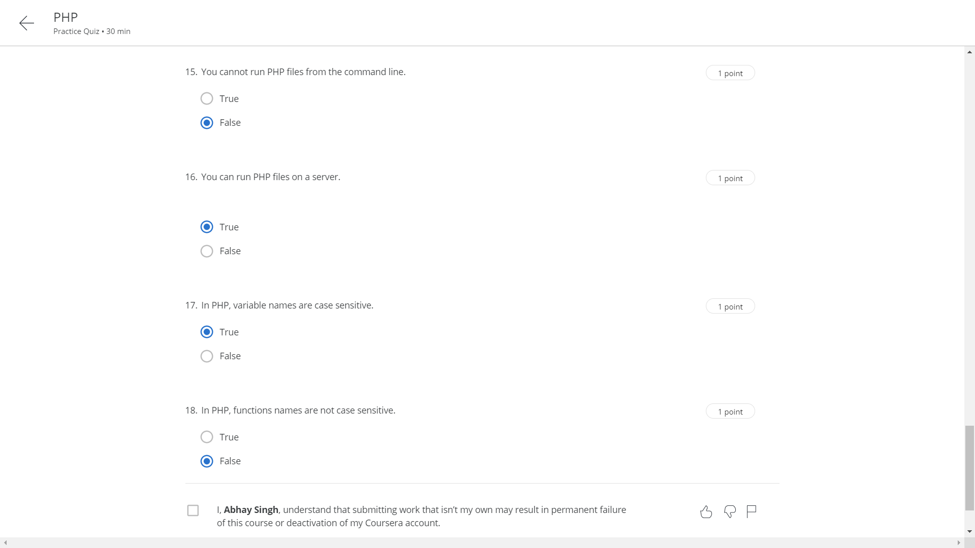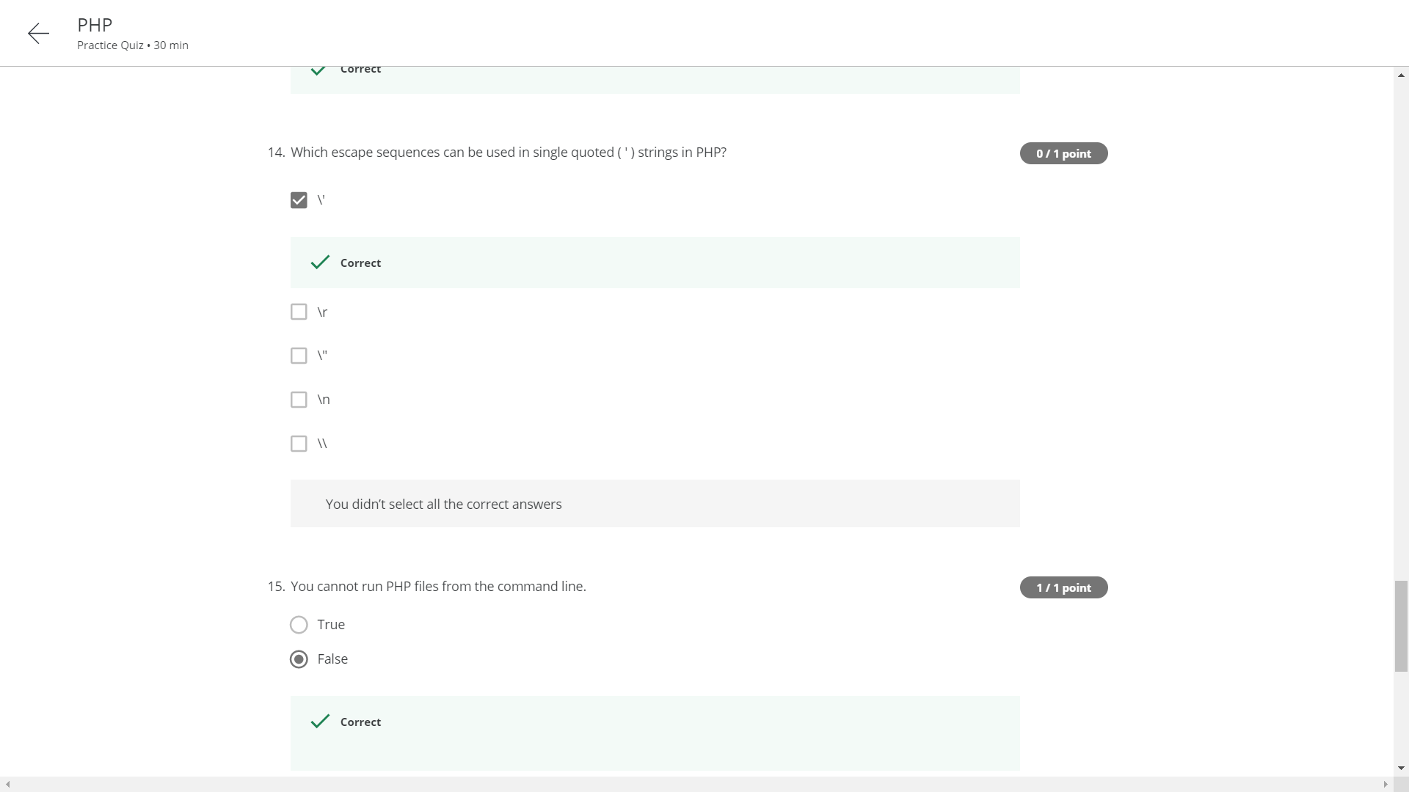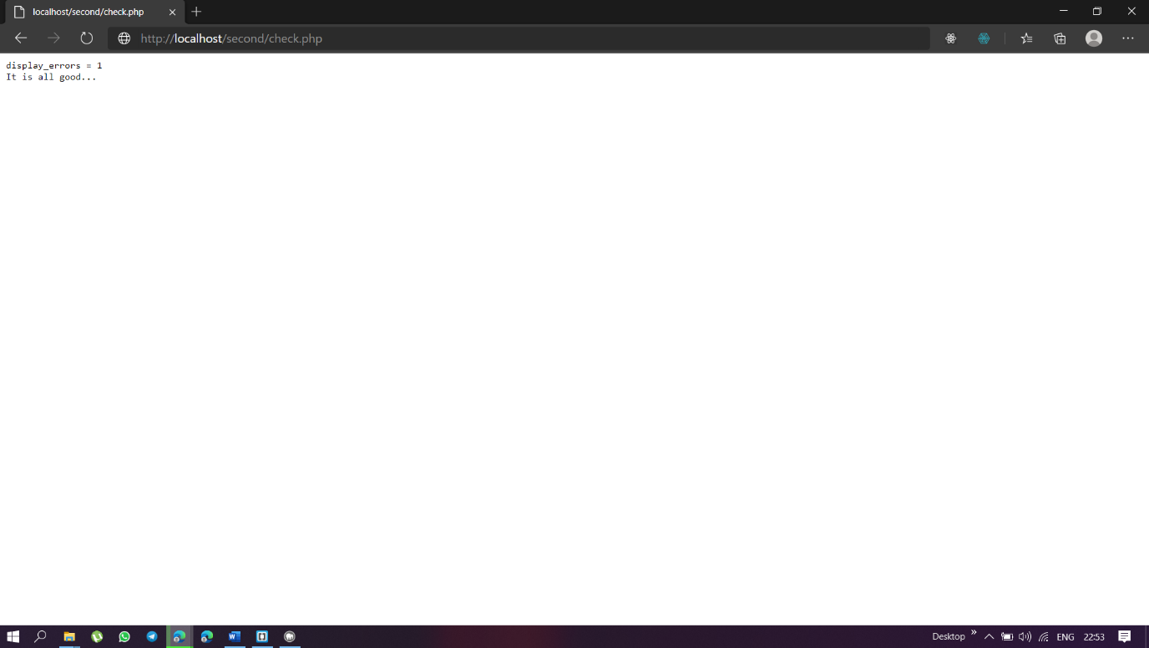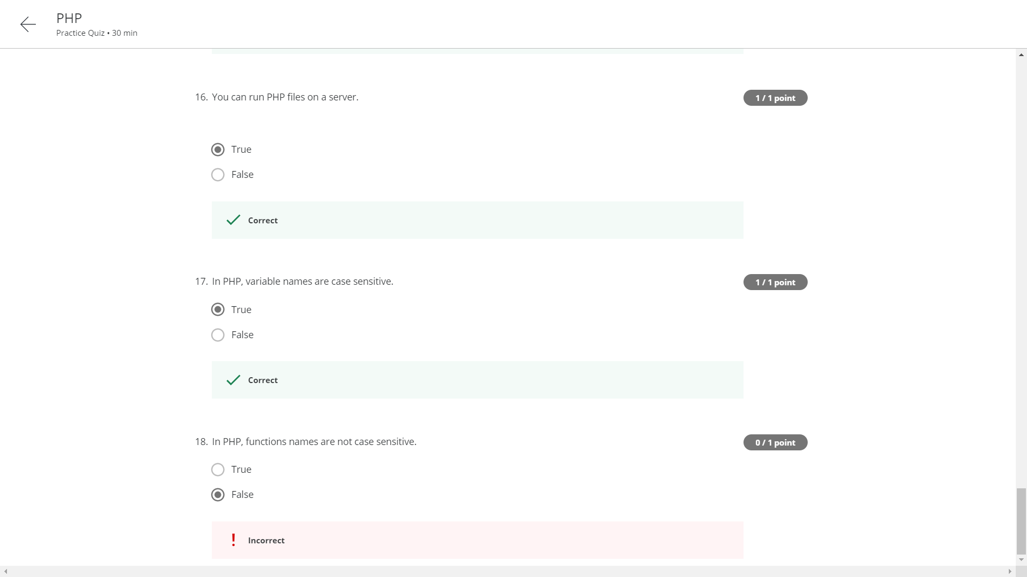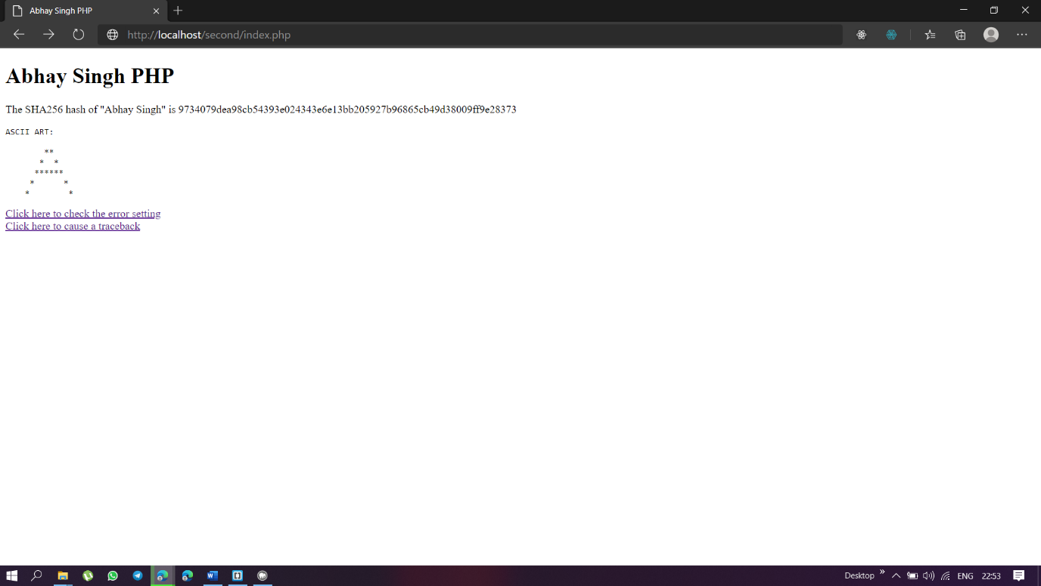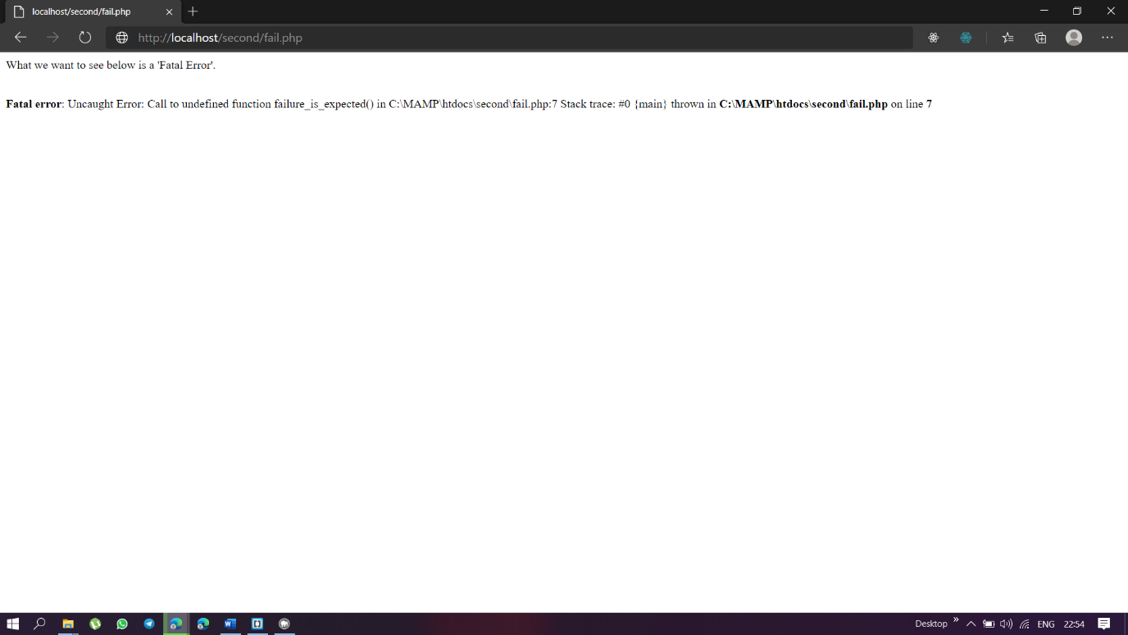

<!DOCTYPE html>

<html>

<head>

<title>Abhay Singh PHP</title>

<meta charset="utf-8" />

</head>

<body>

<h1>Abhay Singh PHP</h1

<p>The SHA256 hash of "Abhay Singh" is

9734079dea98cb54393e024343e6e13bb205927b96865cb49d38009ff9e28373</p>

<pre>ASCII ART:

**

* *

******

* *

* *

</pre>

<a href="check.php">Click here to check the error setting</a>

<br/>

<a href="fail.php">Click here to cause a traceback</a>

</body>

</html>

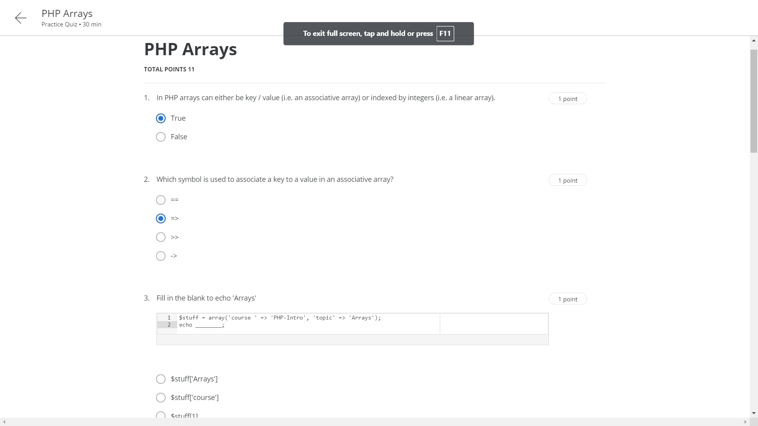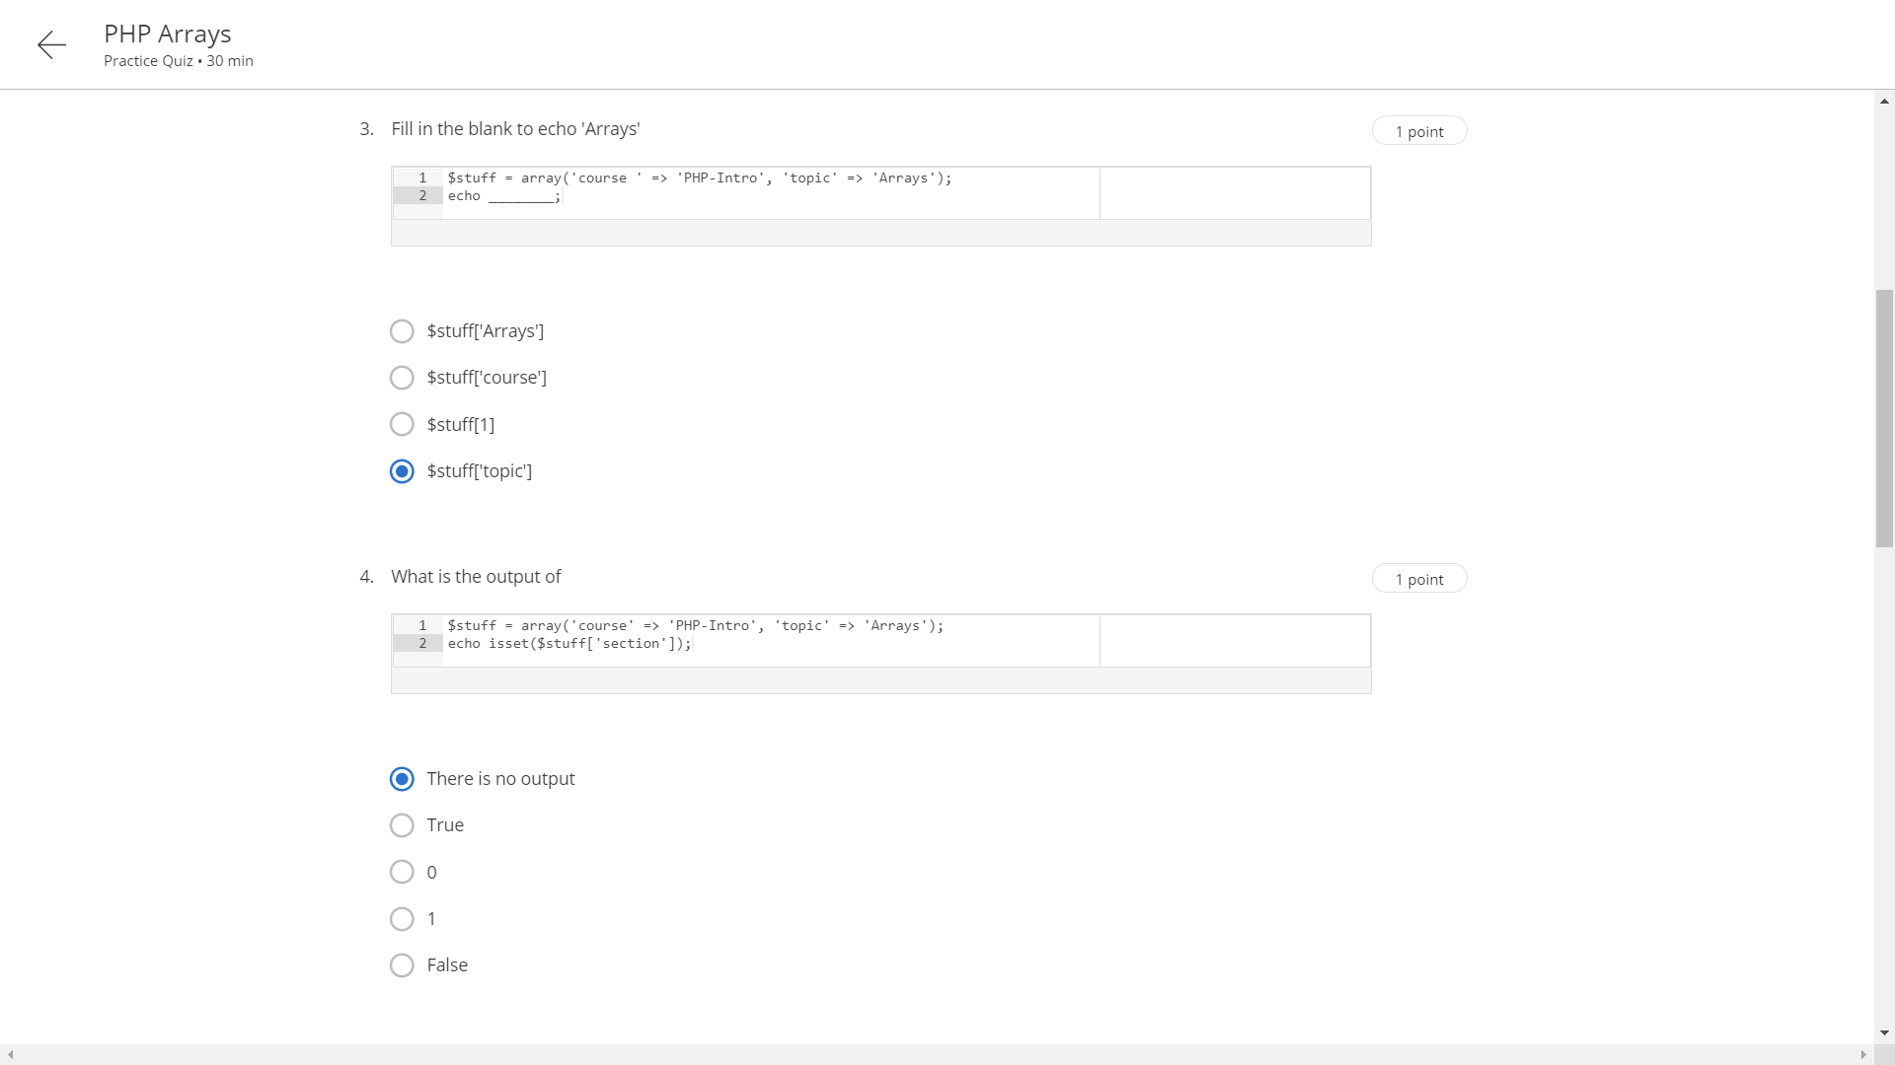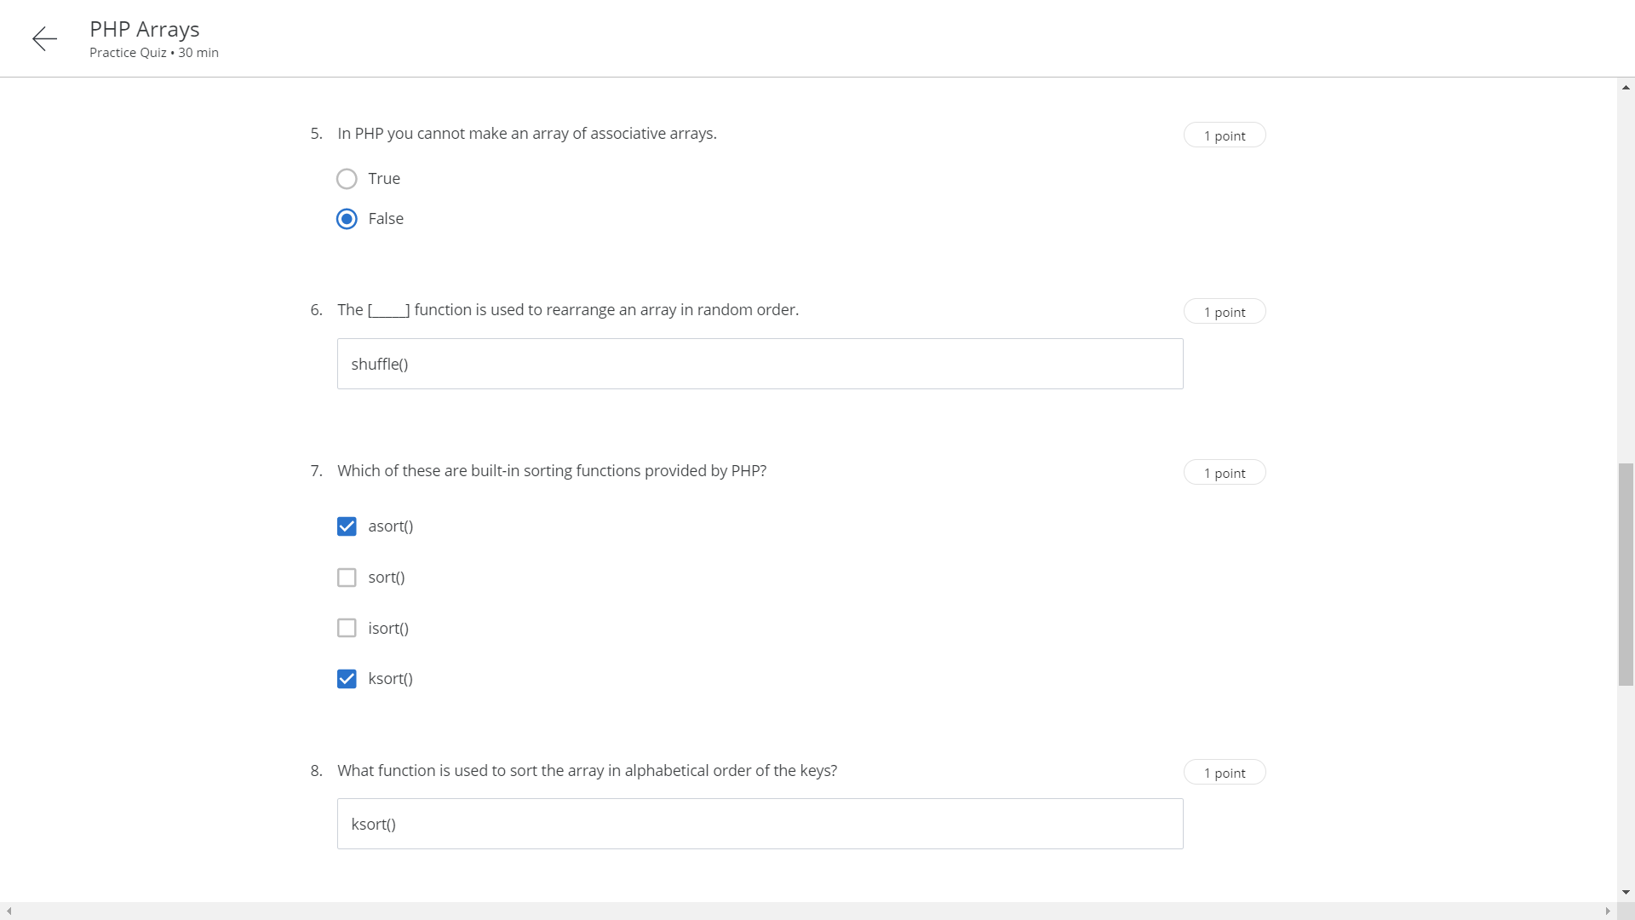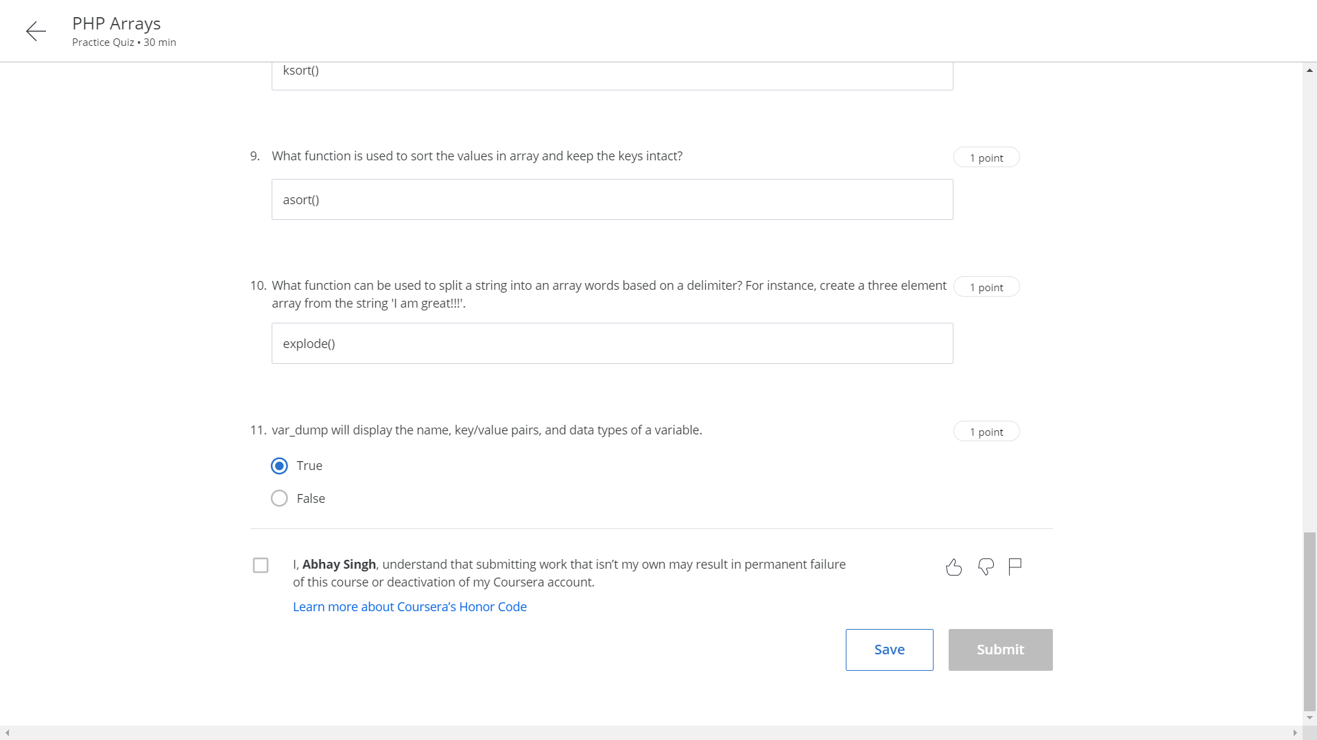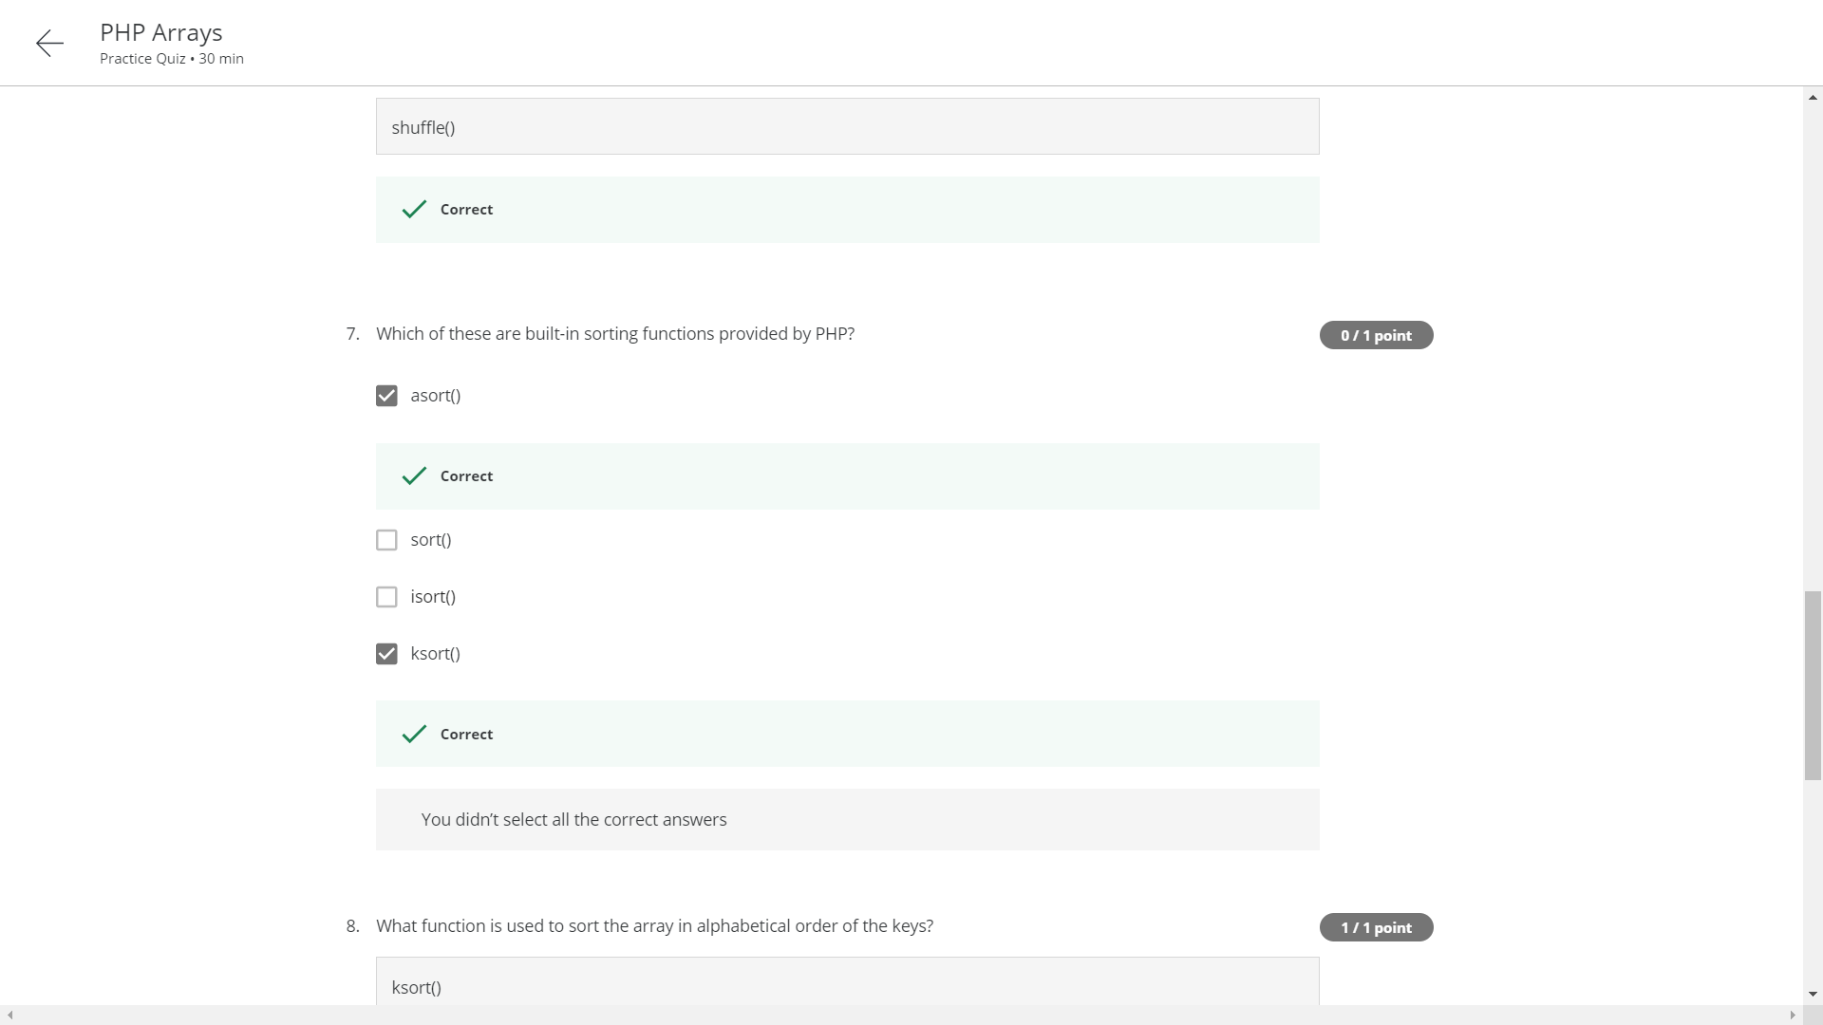

<html>

<head>

<title>Abhay Singh 1521012e</title>

</head>

<body>

<h1> Welcome to my guessing game</h1>

<?php

$correctnumber=33;

$value = $_GET['guess'];

if (isset($value)){

if (is_numeric($value)===FALSE)

{

echo 'Your guess is not a number';

}

else if ($value<$correctnumber)

{

echo 'Your guess is too low';

}

else if ($value>$correctnumber)

{

echo 'Your guess is too high';

}

else if ($value==$correctnumber)

{

echo 'Congratulations - You are right';

}

}

else

{

echo 'Missing guess parameter';

}

?>

</body>

</html>

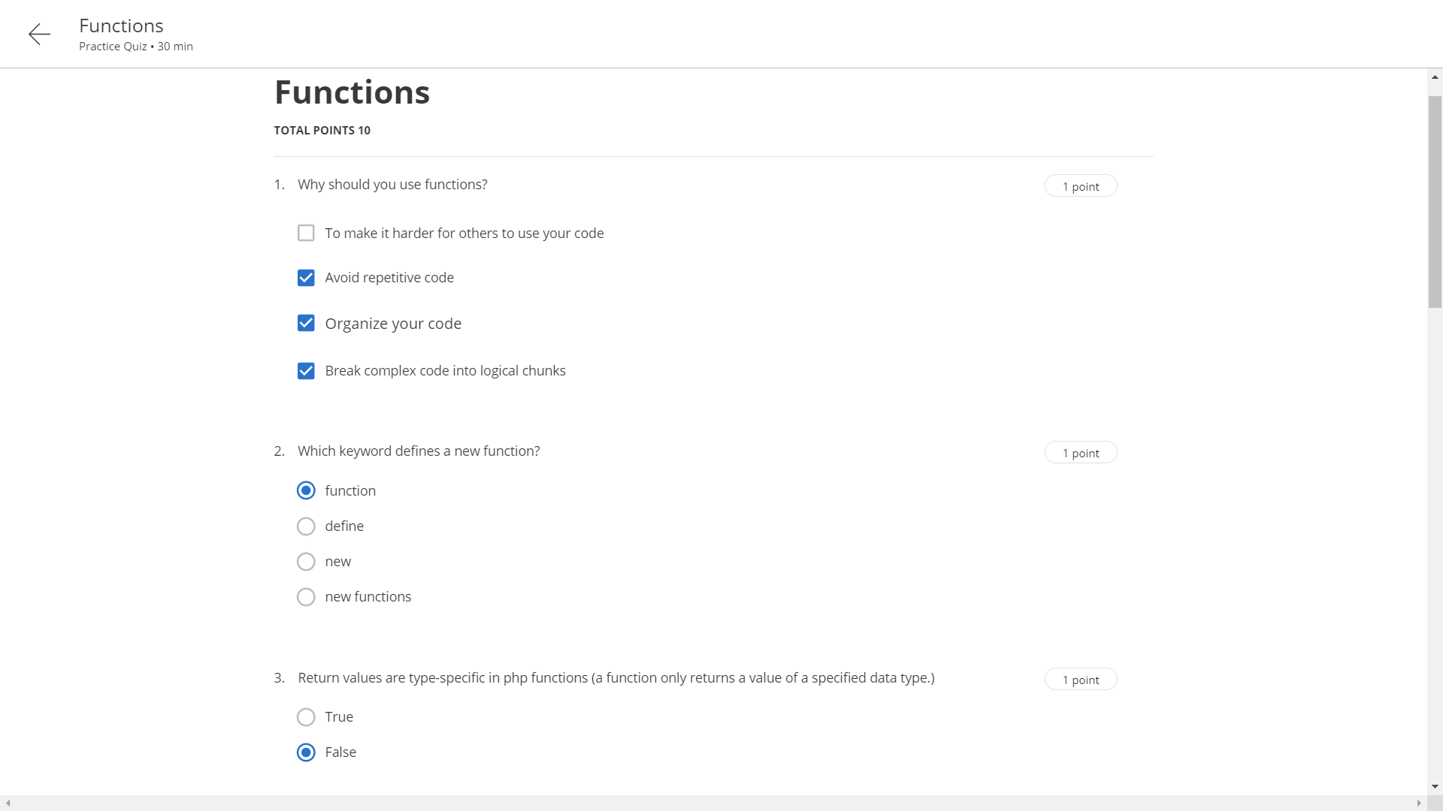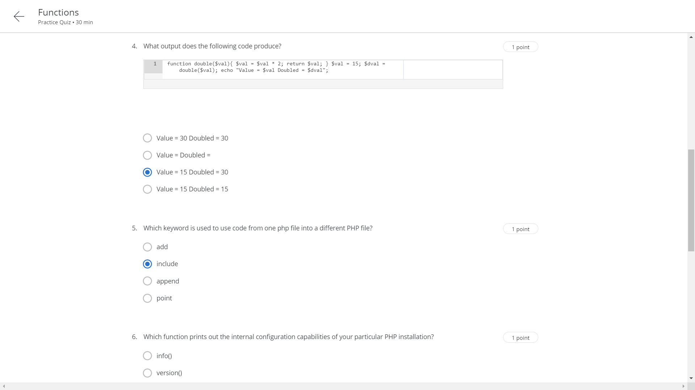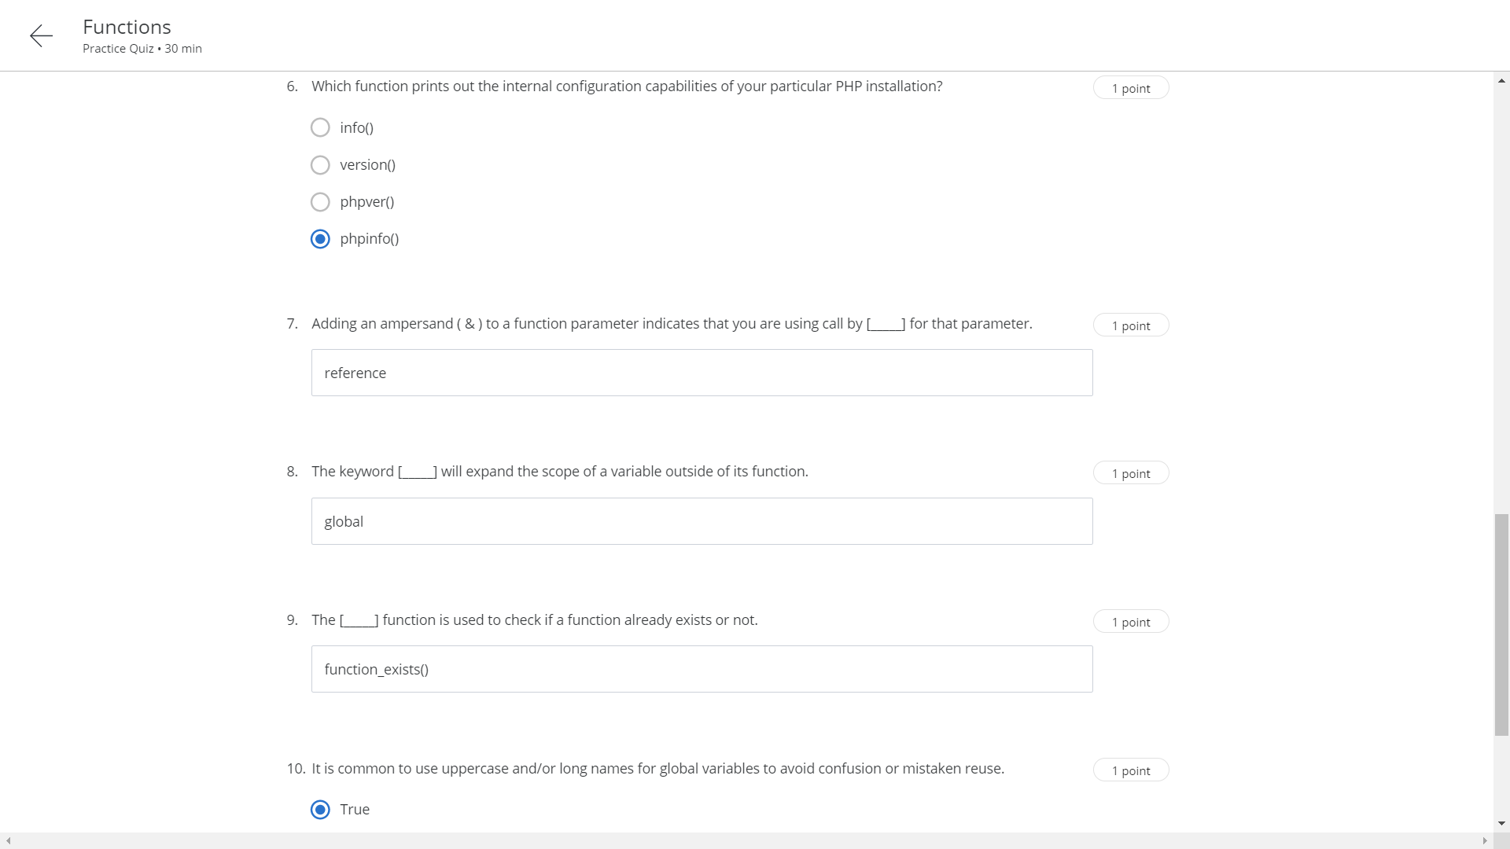

Week 7 assignment

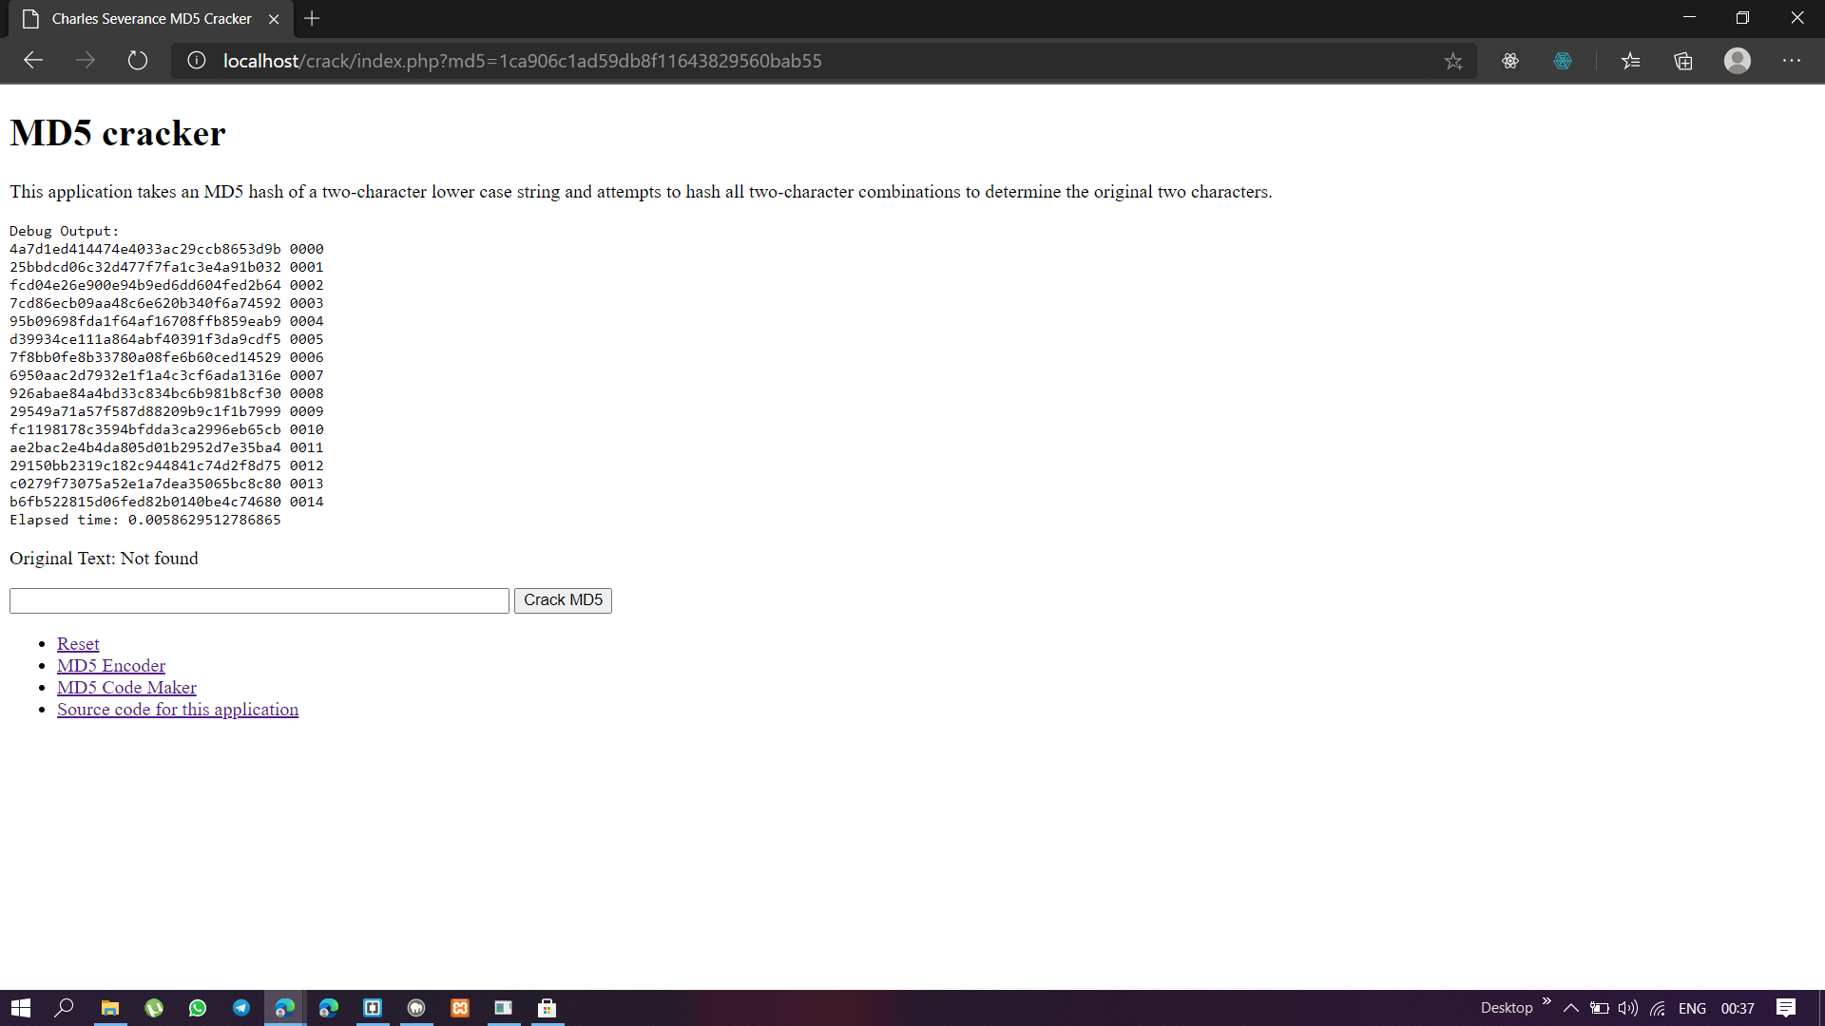

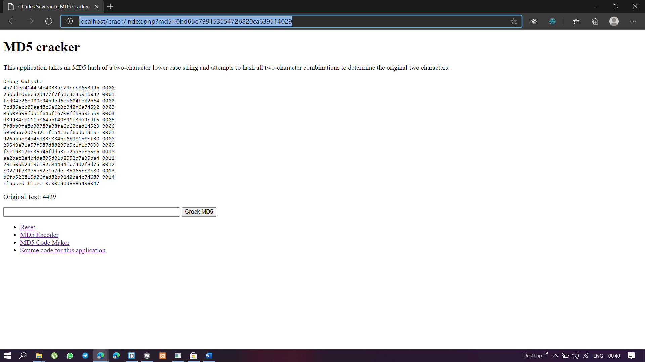

<!DOCTYPE html>

<head><title>Charles Severance MD5 Cracker</title></head>

<body>

<h1>MD5 cracker</h1>

<p>This application takes an MD5 hash

of a two-character lower case string and

attempts to hash all two-character combinations

to determine the original two characters.</p>

<pre>

Debug Output:

<?php

$goodtext = "Not found";

// If there is no parameter, this code is all skipped

if ( isset($_GET['md5']) ) {

// microtime() returns the current Unix timestamp with microseconds. This function is only available on operating systems that support the gettimeofday() system call.

$time_pre = microtime(true);

// echo $time_pre."time pre";

$md5 = $_GET['md5'];

// This is our alphabet

$txt = "0123456789";

$show = 15;

$flag = 0;

for($i=0; $i<strlen($txt); $i++ )

{

$ch1 = $txt[$i]; // The first characters

for($j=0; $j<strlen($txt); $j++ )

{

$ch2 = $txt[$j]; // Our second character

for($k=0; $k<strlen($txt); $k++ )

{

$ch3 = $txt[$k]; // Our third character

for($l=0; $l<strlen($txt); $l++ )

{

$ch4 = $txt[$l]; // Our fourth character

$try = $ch1.$ch2.$ch3.$ch4;

// Run the hash and then check to see if we match

$check = hash('md5', $try);

if ( $check == $md5 ) {

$goodtext = $try;

$flag = 1;

break;

// Exit the inner loop

}

// Debug output until $show hits 0

if ( $show > 0 ) {

print "$check $try\n";

$show = $show - 1;

}

}

if ($flag == 1)

{

break;

}

}

if ($flag == 1)

{

break;

}

}

if ($flag == 1)

{

break;

}

}

// Compute elapsed time

$time_post = microtime(true);

print "Elapsed time: ";

print $time_post-$time_pre;

print "\n";

}

?>

</pre>

<!-- Use the very short syntax and call htmlentities() -->

<p>Original Text: <?= htmlentities($goodtext); ?></p>

<form>

<input type="text" name="md5" size="60" />

<input type="submit" value="Crack MD5"/>

</form>

<ul>

<li><a href="index.php">Reset</a></li>

<li><a href="md5.php">MD5 Encoder</a></li>

<li><a href="makecode.php">MD5 Code Maker</a></li>

<li><a

href="https://github.com/csev/wa4e/tree/master/code/crack"

target="_blank">Source code for this application</a></li>

</ul>

</body>

</html>

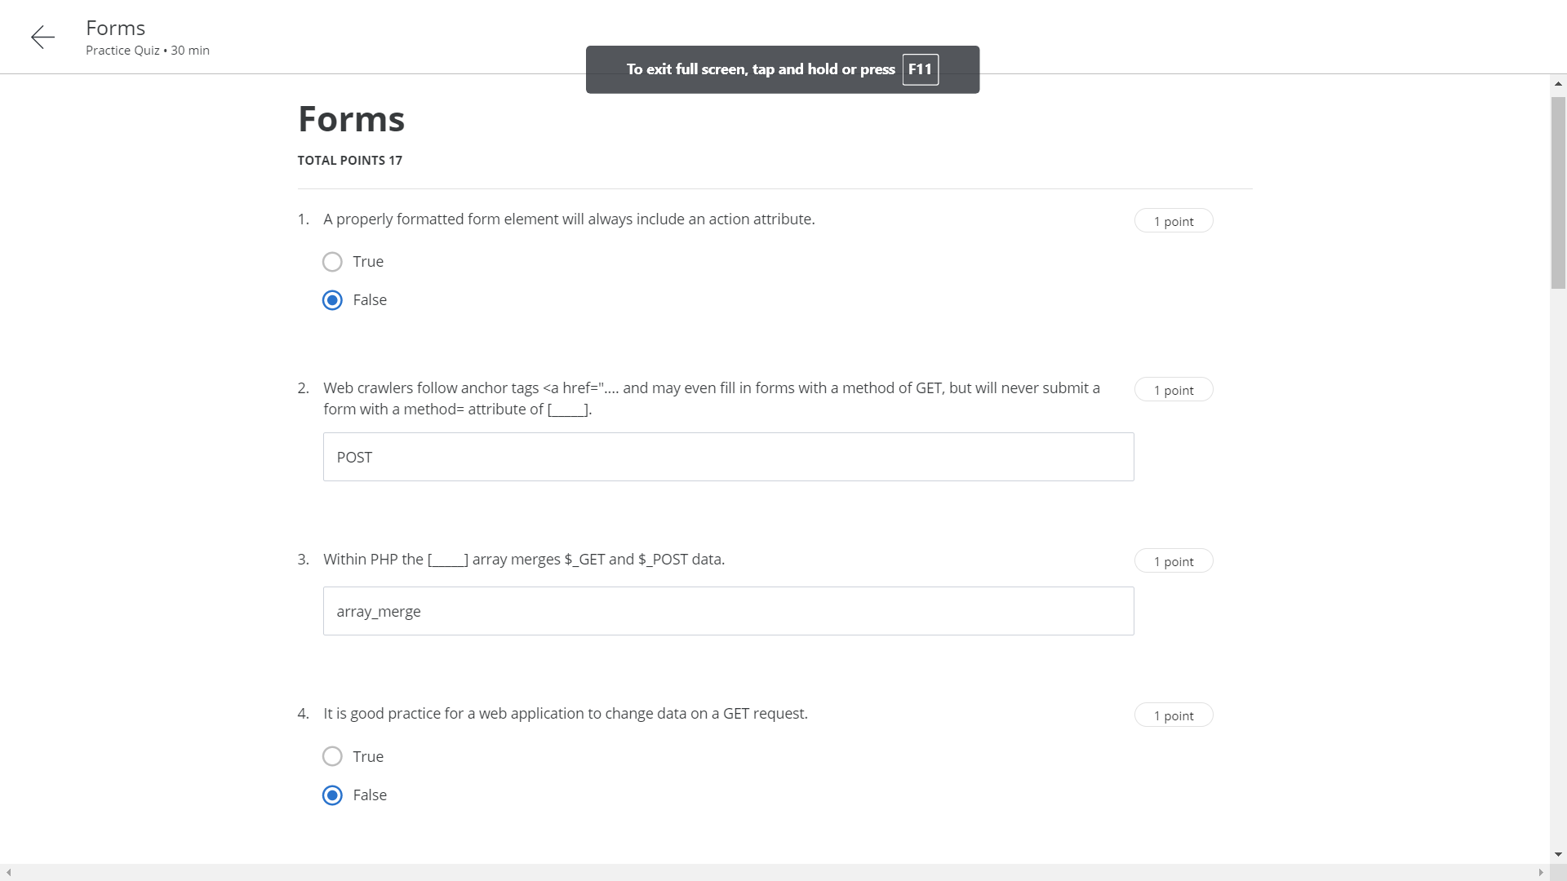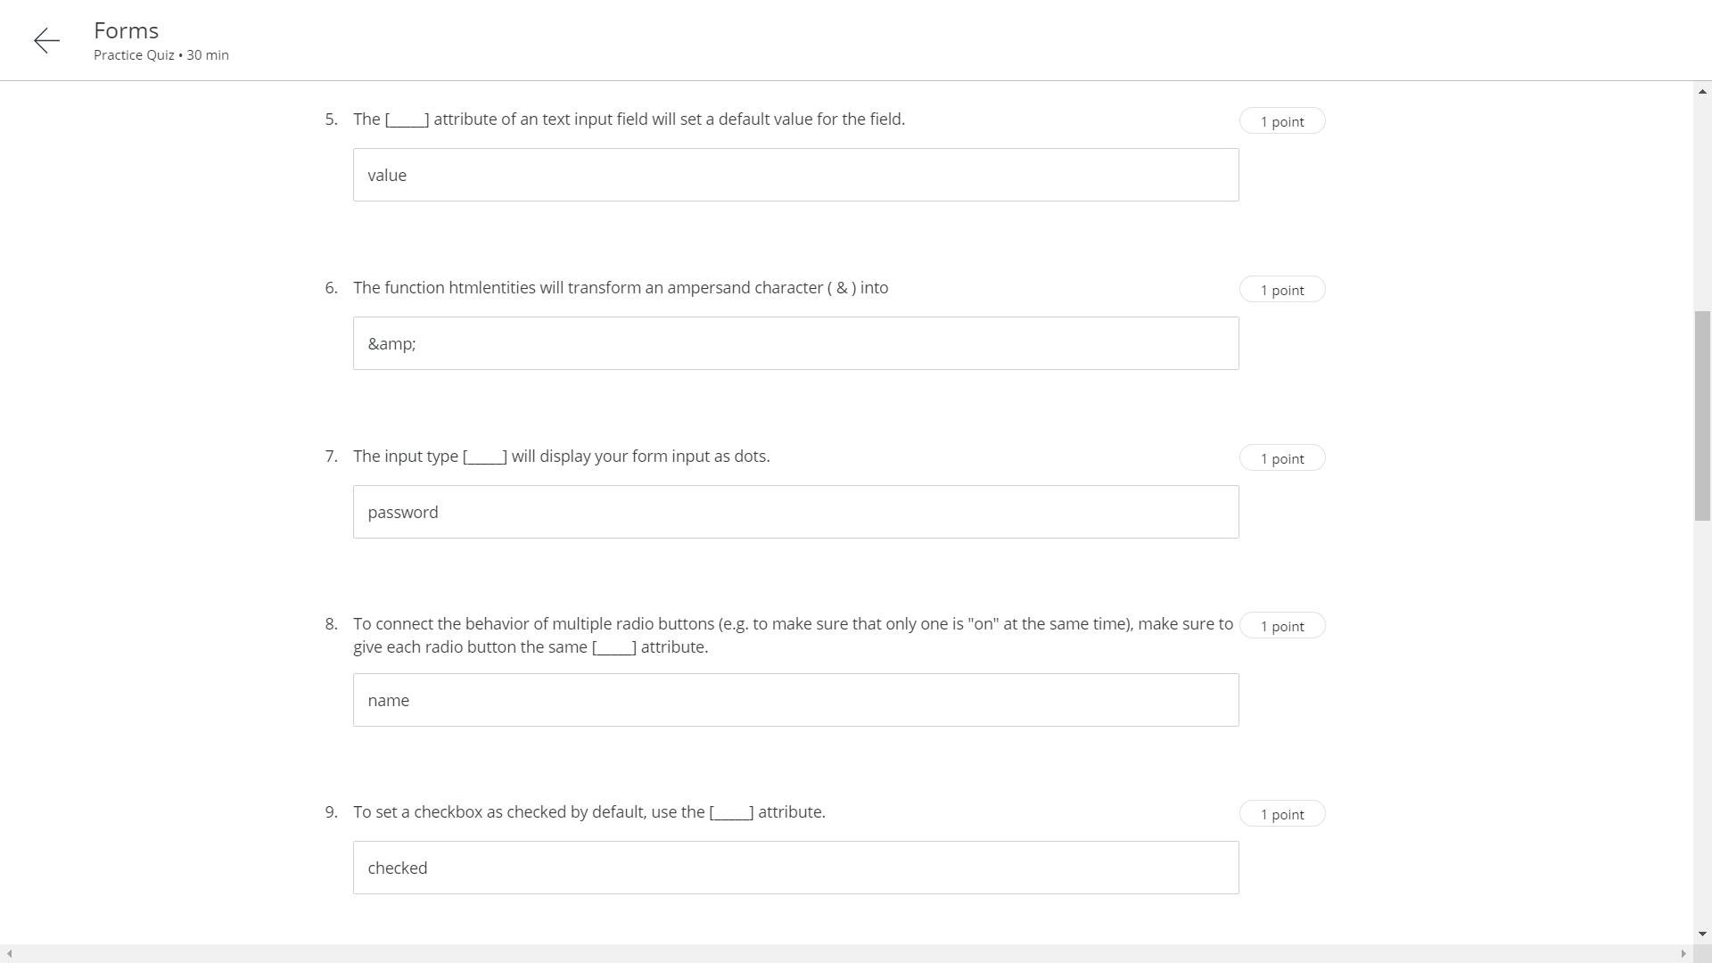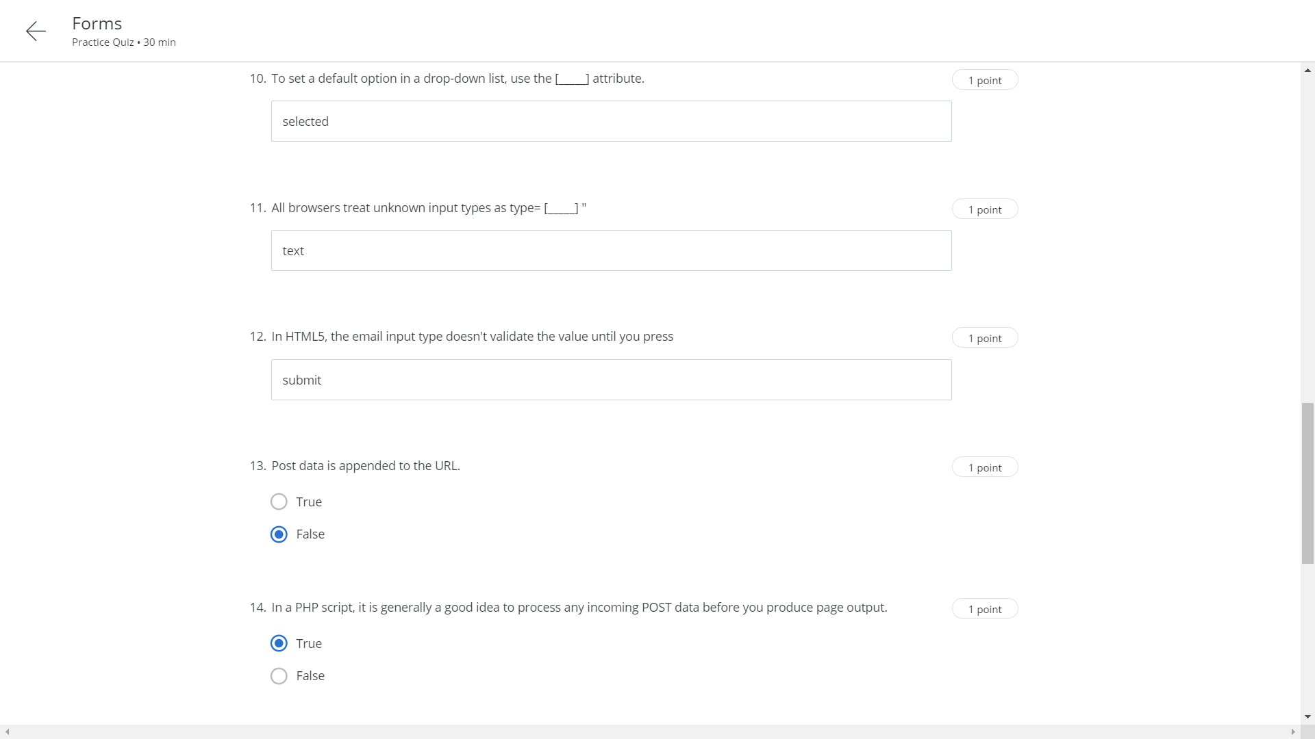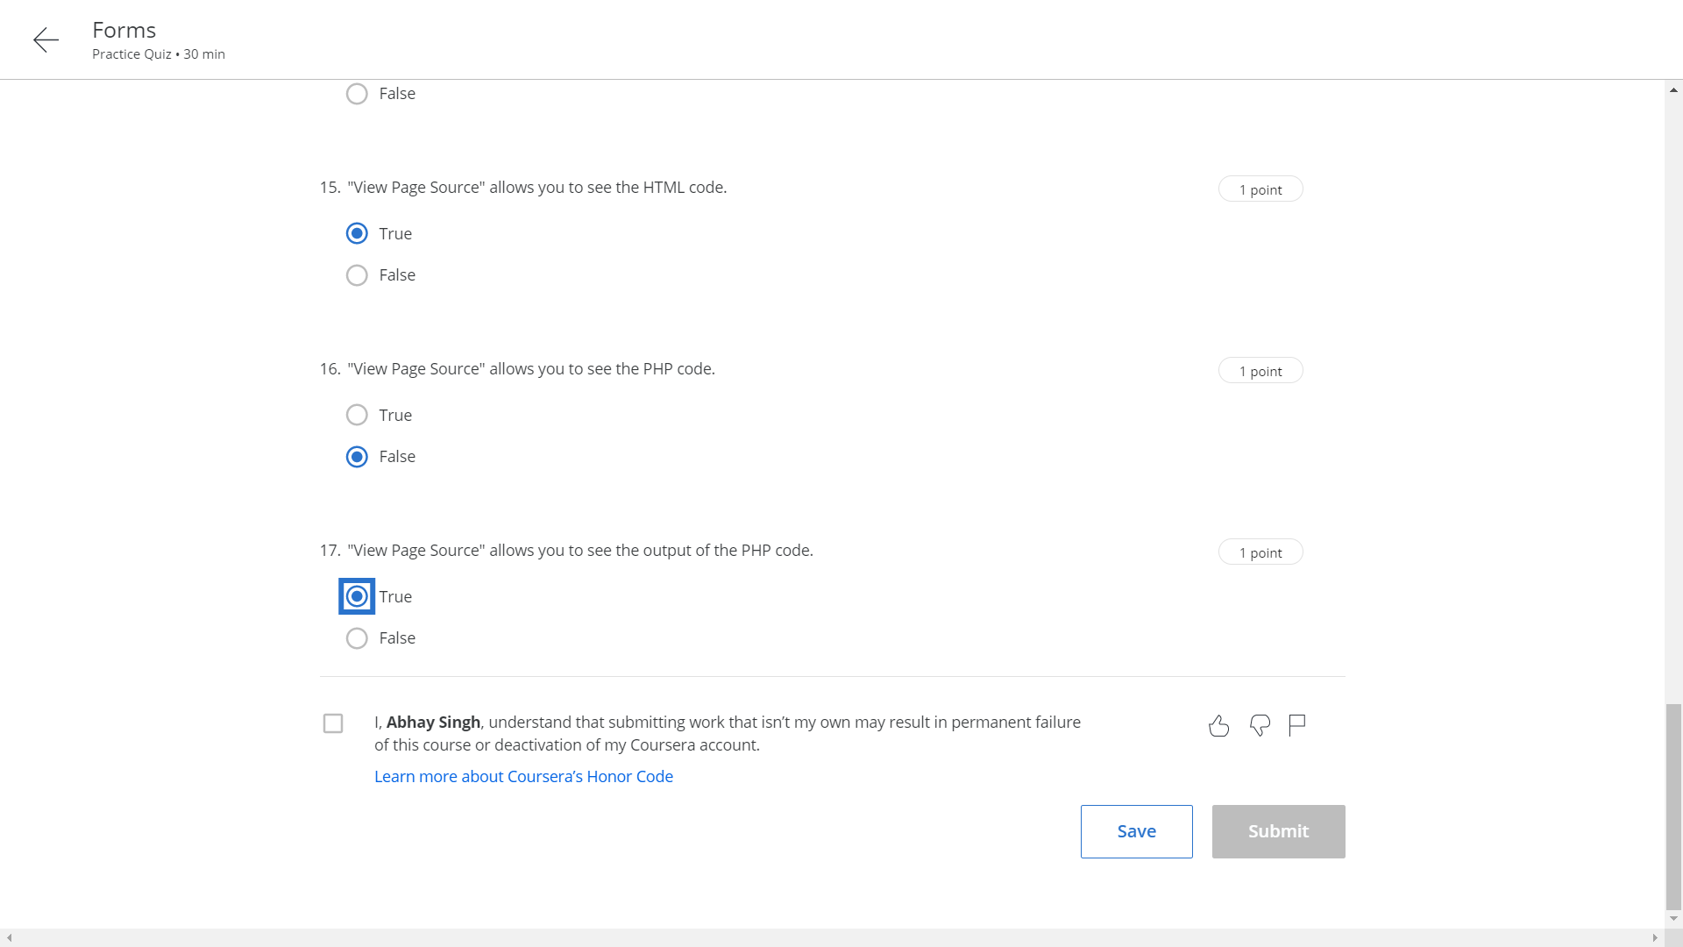

Week 8 assignment

